2. PROJECT MANAGEMENT

2.1 Feasibility Study

Does the system contribute to the overall objectives of the organization?

This system would contribute to the overall objectives of the organization as under
- Create an Office Automation System
- Enhance Productivity
- Enable Prioritization of work.
- Use IT as an enabler to help in daily work
- Design an efficient workplace
- Enable Business Rules based Processing
- Access Controls at all levels.
- Efficient & Transparent administration
- Generation of Report
- Generation of Standard Reports
- Analyzing and monitoring of data

Can the system be implemented using the current technology and within the given cost and schedule constraints?

The part of the system can be implemented using the current technology although some modifications have to be done at various places. Some alterations with the prototypes and functionalities would be done in order to work out the cost constraints and to cope with the scheduling constraints.

Can the system be integrated with other systems which are already in place?
Intelligence Bureau provides Document management, Workflow, Collaboration environment and Knowledge Management in an integrated fashion and delivers as Electronic Workplace that will result in productivity improvement in an Organization. Hence, this Application can be integrated with other systems which are already in place.
Various types of Feasibility study are identified as under:

- Technical Feasibility

The technical Feasibility test involves questions like

- Is the current Computer’s configuration adequate for Usage?

- Is the selected technique sufficient for future enhancements?

- Is the skill set available with proper manpower for development and maintenance?

Also as this system is going to be used by a large organization, it is likely to deal with a large number of data. Security of data is also another important requirement. So, Oracle 10g is more suitable at back-end.

- Operational Feasibility

The users of the client organization should be able to operate the software easily, for whom the software is developed, to gain the advantages of the software. This demands good user interface. During the software development process prototypes of the application are developed initially and are shown to client, so the client can give some additional changes as per their requirements in the operating software. As the software is developed and modified as per the comments of the users, there is very little possibility that there will be resistance from end users.

Users may not be highly adept at the technical aspect of computer skills so will required some training sessions. After that they are expected to be familiarized with the application. System has been developed considering user characteristics to make it user-friendly.

- Economic Feasibility

The questions put forward in economic feasibility are:

- Are there sufficient cost benefits in creating the system?
- Are the costs of implementation of current system so great that the task of project development is required?

This feasibility study measures the cost effectiveness of project. It takes into consideration cost and benefit.

- Hardware-Software Cost

This feasibility is of paramount importance in development of any software for any particular company. TCS is having license versions of software required for the development of Intelligence Bureau. (PLSQL Developer, Microsoft Visual SourceSafe, Oracle 10g). Hardware cost includes the cost of the four servers required for running the application.

- Maintenance Cost

This includes application and database maintenance cost.

Conclusion: It is economically feasible to develop and implement Intelligence Bureau.

2.2 Project Planning

2.2.1 Project Development Approach and Justification

The Requirements provided by the users are converted into Users Requirement Specification as described above. The URS documents are then revised, validated, authorized and approved by the users. The development commences after the approval phase i.e. after the signing off of the URS documents. Thus, the URS is concerned to be the most important document from user and developer prospective. The Developer will try to adhere to the requirements specified in the URS documents in order to develop the required application.

2.2.2 Project Plan

TCS has a very long-standing relationship at client side, having logged over 4,500 people. It has provided its expertise to various agencies all over the world, working with numerous hardware and software technologies, to improve its overall image and provide better services to its constituents. TCS will bring its vast domain expertise, knowledge of the best practices and lessons learnt in various implementations at client side to this project. For this specific requirement analysis, TCS consultants with the help of designated personnel from CLIENT would familiarize themselves with the overall structure of the office and it’s inter-linkages with other departments/systems. They will understand the broad working of the office and the other related departments, its functions, manpower employed, processes etc.

TCS consultants shall meet the representative personnel and document the detailed gaps between the current system and the proposed solution based on the understanding of the activities and processes, as they are currently being carried out in the office.

The gaps would be documented and analyzed, and if required and possible reengineering of process in concurrence with CLIENT to leverage the benefits of the product would be suggested.

Other areas, which would be considered during the planning and analysis, would be:

- Ensure that the information flow is process driven.
- Reduce the manual efforts to the maximum extent for all activities.
- Ensure on-line validation and feedback of data.
- Act as an effective tool in decision support.
- Provide audit control check points.

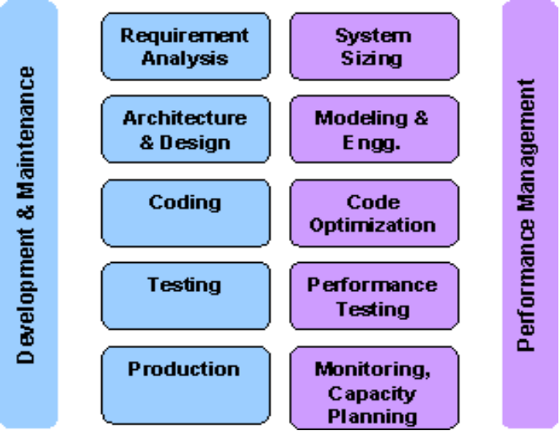
Fig 2.2.2.1 Project Planning and Management Approach

Internal Training

TCS will conduct necessary training for the TCS’ project team to carry out the proposed project. This will be in addition to the regular extensive training program that is conducted by TCS for its staff and trainees.

2.2.3 Milestones and Deliverables

Milestones are identified in order to complete the entire project in the time duration. Milestones are identified for every module of Integrated Workflow Document Management System.

PHASE | DELIVERABLES | PURPOSE
System Requirement and Analysis | - Requirement Gathering and analysis.  - Functional Specifications  Non Functional Specifications | It gives exact understanding of the user’s requirements.
System Design | - E-R Diagram  - Database Design  - Class diagram  - Sequence Diagram  - Use Case Diagram  - Form layouts | It gives the logical structure that describes the system.
Implementation and Testing | The output obtained for the required functionality after implementing and doing various types of testing | It gives the required module

Table 2.2.3.1 Milestones and Deliverables

2.2.4 Roles and Responsibilities

TCS proposes the following Project Management structure for the successful development/customization, implementation and maintenance of the Intelligence Bureau system.
The following is the recommended Project Management structure for the execution of the project.

Project Team Structure

TCS proposes the following team structure for the successful implementation of the project. The TCS team will be headed by a Project Manager and will be supported by Project Leaders/Module Leaders and Team Members and Trainees.

TCS proposes a multi-disciplinary team for the project. TCS would draw in knowledge from its pool of resources with expertise ranging from business domain to the systems administration, systems architect, and Networking and Internet technology. These experts will act as consultants to the TCS Intelligence Bureau project team. Other enabling groups within TCS such as Quality Assurance, Manpower Allocation Task Committee, Operations and Training have important role in the successful execution of the project.

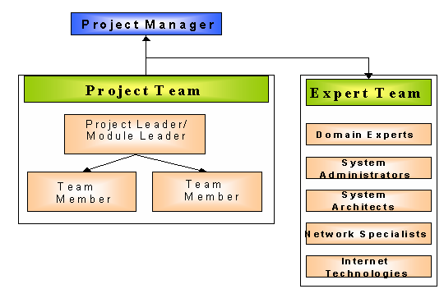
Fig 2.2.4.1 Project Team Structure

Project Manager
The responsibilities of the Project Manager are:

- Overall management and functioning of the Intelligence Bureau project
- Project Planning
- Monitoring the progress & status of the project on a regular basis
- Managing the TCS-CLIENT project resources and resource allocation
- Managing the flow of work
- Co-ordinate with Project Manager (PM for Intelligence Bureau) of CLIENT for acceptance for various deliverables
- Co-ordinate with Project Manager (PM for Intelligence Bureau) of CLIENT for the approvals required at various stages of the project, including signing off of the gap analysis document, Acceptance of the product/solution etc.
- Change Management: Identifying and evaluating the changes to the scope and content of work during the project, which may impact the original budget and schedule.
- Reporting status on a Monthly basis to Project Manager (PM for Intelligence Bureau) of CLIENT and TCS Management
- Ensuring the quality of the deliverables

Project Leader
The responsibilities of the Project Leader are:

- Planning the application customization/development work in the Intelligence Bureau Project.
- Monitoring the day-to-day status of application development/customization activities in the Intelligence Bureau project.
- Planning and scheduling of enhancement to Intelligence Bureau system in co-ordination with Project Manager (CLIENT) and Project Manager (TCS).
- Liaison with various Intelligence Bureau functionality champions and Project Manager (PM for Intelligence Bureau) of CLIENT, for the gap analysis study.
- Ensuring the quality of the deliverables.
- Obtain clarifications necessary from the Project Management team regarding Functionality, GUI design etc over telephone (teleconference) or e-mail.
- Manage the flow of work within his/her team and allocate work to team members.
- Monitor the Quality of the deliverables being created.
- Change Management: Maintain a clarification document and ensure that any change or clarification is reflected in the design documents.
- Reporting status to the Project Manager on a weekly basis.

Module Leader
The responsibilities of a Module Leader include:

- Responsible for the work related to his/her group
- Allocate work to his module members
- Participate in Gap Analysis, Creation of SRS, Creation of the Design Document and provide required support to the project team in the development of the system
- Co-ordinate testing
- Perform Defect analysis and take corrective actions
- Ensure all the documentation with respect to the module is complete and up to date
- Change Management
- Report on a weekly basis the status of the module to the Project leader

Team member
The responsibilities of a team member include:
- Carrying out the work allocated
- Report on a weekly basis to Module Leader

2.2.5 Group Dependencies

Module Leaders will report the progress of work in their respective modules to the Project Leader on a weekly basis. The Project Leaders will in turn submit weekly status reports to the concerned Project Managers. The status report will contain:
- Activities completed since last report
- Activities planned until the next report
- Progress against plan
- Deliverables to CLIENT since last report
- Deliverables due to CLIENT in the next reporting period
- Outstanding issues

The Project Manager will monitor the progress of the activities against the plan and prepare a consolidated Monthly Report to Project Manager (PM) of CLIENT. This report will cover the project status and deviations against plan.
Future:
The implementation of the framework in other regional office will yield the following benefits:
- Knowledge-led governance
- Aid in policy formulation
- Consistency of applications across all levels
- Elimination of data redundancy
- Interoperability
- Easy flow of information

2.3 Project Scheduling

2.3.1 Time Allotted to Various Activities
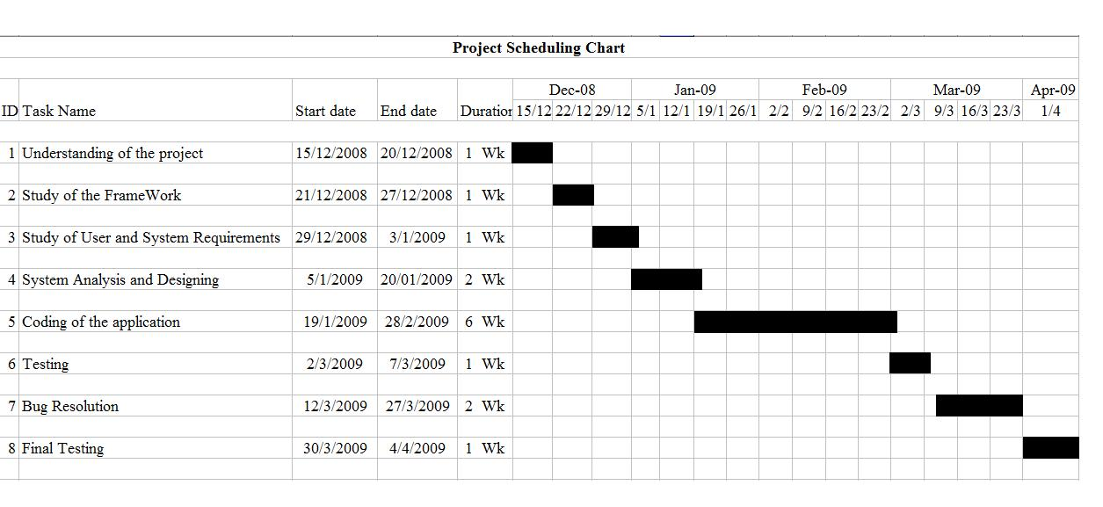Fig 2.3.1 Time Allotted to Various Activities

